**ITCC 298 Product Project**

**Linear Study Aid**

**A python-based study tool**

**Developed by Caleb Howard**

**Table Of Contents**

**System Requirements………………………………………………………………………………………3**

**Relevant Documents………………………………………………………………………………………..4**

**Introduction and Safety message……………………………………………………………………..5**

**Getting Started…………………………………………………………………………………………………6**

**Figure 1**

**Figure 2**

**Figure 3**

**Figure 4**

**Figure 5**

**Making your Questions……………………………………………………………………………….10**

**Figure 6**

**Figure 7**

**Figure 8**

**SYSTEM REQUIREMENTS**

* Python Installation – will come with a python interpreter
* Intel Core i5 processor or equivalent
* 4 GB RAM (8 GB preferred)
* 15 GB available hard disk space
* Internet connection

Relevant Documents

Ref 1: [Pycharm is a recommended and free Aid](https://www.jetbrains.com/products/compare/?product=pycharm&product=pycharm-ce)

Ref 2: [Tom’s Hardware article going over checking your system components](https://www.tomshardware.com/how-to/check-pc-specs-windows)

Introduction

This is a free module that you can use to study any topic with set questions and answers. Feel free to modify or take any portion of this tool and re-purpose it as you need. This guide is intended to help you set up the tool and run it using Pycharm 2023.1.3 as an editing tool. This guide is accurate only within the current configuration of the module and will likely not work if modifications outside the scope of what is covered here are made.

Safety

There are no specific safety requirements or practices for this program. However, I want to remind you to exercise caution when downloading files from unknown sources. With the ever-evolving landscape of the digital world, it's crucial to be vigilant and proactive in safeguarding your devices and personal information. This tool is available free of charge but not all services that are the same are safe. Use your best judgement and avoid navigating to sites you don’t know or trust.

Getting Started

1. Before you can use this module, you will need to have python API installed on your device, you can use Ref 1 to install the program. You may need to check if your system meets the minimum requirements to run python, you can do that using Ref 2.
2. Ref 2 will take you to a page that looks like figure 1. Scroll to the bottom of the page to where you see download on the PyCharm Community Edition like in figure 2.

Figure

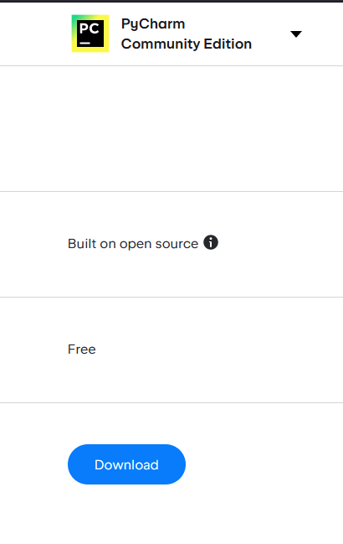



Figure

1. After Clicking on the link, you will be taken to a download screen, DO NOT click download, instead navigate to other versions highlighted in red by figure 3.



Figure

1. Download the community version of your operating system (Windows, MacOS, or Linux) shown on the screen and circled in red in figure 4.

Figure



1. From your downloads you will need to run the program as an administrator to install.

Figure

1. Follow the instructions inside the installation wizard for the easiest experience. I would recommend checking the box that asks if you would like to make a desktop shortcut for ease of use, and to create associations with .py files.
2. After installing, click on the shortcut you created. You should see the option to open a file, navigate to where you saved the tool (ITCC298_Final.py) and highlight it, then press ok.

That is all you need to do to get started, the next section will cover modifying the questions library to fit your needs

Making your Questions

1. You should see the Import command at the top of the file, with the rest matching Figure 6.

Figure

1. Navigate to the hash “# Enter Questions here, you can add more to library by copying the syntax and changing the values”
2. Inside of the bracket you need to change the values inside the right side of the quotes to match the questions and answers you would like to quiz yourself on



Figure

Red is the question, as indicated by the value left of it, and Blue is the answer which is denoted likewise.

The syntax of each value must be the same. An example is listed below.

{

"question": "XXXXXXXXX",

"answer": "XXXXXX"

}

The braces {} must be indented following the bracket above after all questions are entered.

1. After all questions are entered, save the File by going to File > Save as > and naming the file what you want.
2. Navigate to the top right of the application and you will see a green play button. Press it and the File should run.



Figure

1. Ensure that the file in the drop-down menu left of the play button says current file. This could resolve any issues you have with executing the file.

And that is it, you can run this file from console as well once it is saved, but you will need to open it in a text editor or Pycharm to make further changes to the pool of questions.